**Class:** Final Year (Computer Science and Engineering)

**Year:** 2023-24 **Semester:** 1

**Course:** High Performance Computing Lab

**Practical No. 5**

**Exam Seat No: 2020BTECS00037**

**Title of practical: Implementation of OpenMP programs.**

Implement following Programs using OpenMP with C:

1. Implementation of sum of two lower triangular matrices.
2. Implementation of Matrix-Matrix Multiplication.

**Problem Statement 1:**

**matrix_sum_serial**

#include <stdio.h>

#include <time.h>

// Size of the matrices

#define N 4

int main() {

    // Lower triangular matrices

    int A[N][N];

    int B[N][N];

    // Resultant matrix

    int C[N][N];

    clock_t start_time, end_time;

    // Initialize matrices A and B

    for (int i = 0; i < N; i++) {

        for (int j = 0; j <= i; j++) {

            A[i][j] = i + j + 1;

            B[i][j] = i - j + 1;

        }

    }

    start_time = clock();

    for (int i = 0; i < N; i++) {

        for (int j = 0; j <= i; j++) {

            C[i][j] = A[i][j] + B[i][j];

        }

    }

    end_time = clock();

    printf("Resultant Matrix C:\n");

    for (int i = 0; i < N; i++) {

        for (int j = 0; j <= i; j++) {

            printf("%d ", C[i][j]);

        }

        printf("\n");

    }

    double exec_time = (double)(end_time - start_time) / CLOCKS_PER_SEC;

    printf("\nExecution time = %.6f seconds\n", exec_time);

    return 0;

}

**Screenshots:**

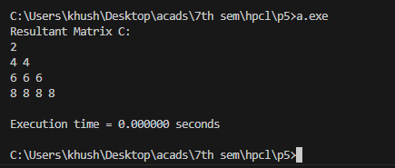

1. **Implementation of Matrix-Matrix Multiplication.**

**Problem Statement 2:**

**matrix_mul_serial**

#include <stdio.h>

#include <stdlib.h>

#include <sys/time.h>

#define ROWS_A 8

#define COLS_A 8

#define ROWS_B 8

#define COLS_B 8

double get_seconds(struct timeval start, struct timeval end) {

    return (end.tv_sec - start.tv_sec) + (end.tv_usec - start.tv_usec) / 1e6;

}

int main() {

    srand(time(NULL));

    struct timeval start_time, end_time;

    int A[ROWS_A][COLS_A];

    int B[ROWS_B][COLS_B];

    int C[ROWS_A][COLS_B];

    // Initialize matrices A and B with random values

    for (int i = 0; i < ROWS_A; i++) {

        for (int j = 0; j < COLS_A; j++) {

            // Random values between 0 and 99

            A[i][j] = rand() % 100;

        }

    }

    for (int i = 0; i < ROWS_B; i++) {

        for (int j = 0; j < COLS_B; j++) {

            // Random values between 0 and 99

            B[i][j] = rand() % 100;

        }

    }

    gettimeofday(&start_time, NULL);

    // Perform matrix multiplication

    for (int i = 0; i < ROWS_A; i++) {

        for (int j = 0; j < COLS_B; j++) {

            C[i][j] = 0;

            for (int k = 0; k < COLS_A; k++) {

                C[i][j] += A[i][k] * B[k][j];

            }

        }

    }

    gettimeofday(&end_time, NULL);

    // Print the result matrix C

    printf("Matrix A:\n");

    for (int i = 0; i < ROWS_A; i++) {

        for (int j = 0; j < COLS_A; j++) {

            printf("%d ", A[i][j]);

        }

        printf("\n");

    }

    printf("\nMatrix B:\n");

    for (int i = 0; i < ROWS_B; i++) {

        for (int j = 0; j < COLS_B; j++) {

            printf("%d ", B[i][j]);

        }

        printf("\n");

    }

    printf("\nResultant Matrix C:\n");

    for (int i = 0; i < ROWS_A; i++) {

        for (int j = 0; j < COLS_B; j++) {

            printf("%d ", C[i][j]);

        }

        printf("\n");

    }

    double exec_time = get_seconds(start_time, end_time);

    printf("\nExecution time = %.6f seconds\n", exec_time);

    return 0;

}

**Screenshots:**

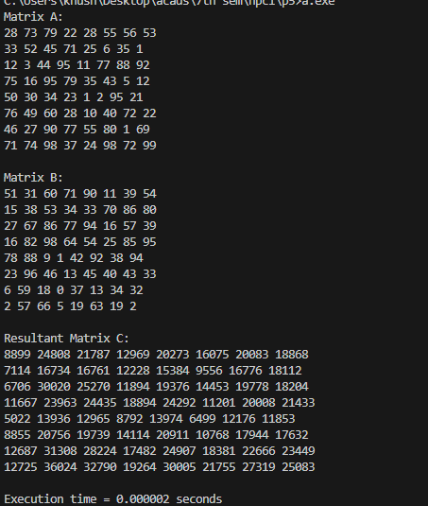

**Parallel**

#include <stdio.h>

#include <stdlib.h>

#include <time.h>

#include <omp.h>

#define ROWS_A 8

#define COLS_A 8

#define ROWS_B 8

#define COLS_B 8

int main() {

    srand(time(NULL));

    double start_time, end_time;

    int A[ROWS_A][COLS_A];

    int B[ROWS_B][COLS_B];

    int C[ROWS_A][COLS_B];

    // Initialize matrices A and B with random values

    for (int i = 0; i < ROWS_A; i++) {

        for (int j = 0; j < COLS_A; j++) {

            // Random values between 0 and 99

            A[i][j] = rand() % 100;

        }

    }

    for (int i = 0; i < ROWS_B; i++) {

        for (int j = 0; j < COLS_B; j++) {

            // Random values between 0 and 99

            B[i][j] = rand() % 100;

        }

    }

    start_time = omp_get_wtime();

    omp_set_num_threads(8);

    // Perform matrix multiplication

    for (int i = 0; i < ROWS_A; i++) {

        for (int j = 0; j < COLS_B; j++) {

            C[i][j] = 0;

            for (int k = 0; k < COLS_A; k++) {

                C[i][j] += A[i][k] * B[k][j];

            }

        }

    }

    end_time = omp_get_wtime();

    // Print the result matrix C

    printf("Matrix A:\n");

    for (int i = 0; i < ROWS_A; i++) {

        for (int j = 0; j < COLS_A; j++) {

            printf("%d ", A[i][j]);

        }

        printf("\n");

    }

    printf("\nMatrix B:\n");

    for (int i = 0; i < ROWS_B; i++) {

        for (int j = 0; j < COLS_B; j++) {

            printf("%d ", B[i][j]);

        }

        printf("\n");

    }

    printf("\nResultant Matrix C:\n");

    for (int i = 0; i < ROWS_A; i++) {

        for (int j = 0; j < COLS_B; j++) {

            printf("%d ", C[i][j]);

        }

        printf("\n");

    }

    double exec_time = end_time - start_time;

    printf("\nExecution time = %lf seconds\n", exec_time);

    return 0;

}

**Screenshots:**

